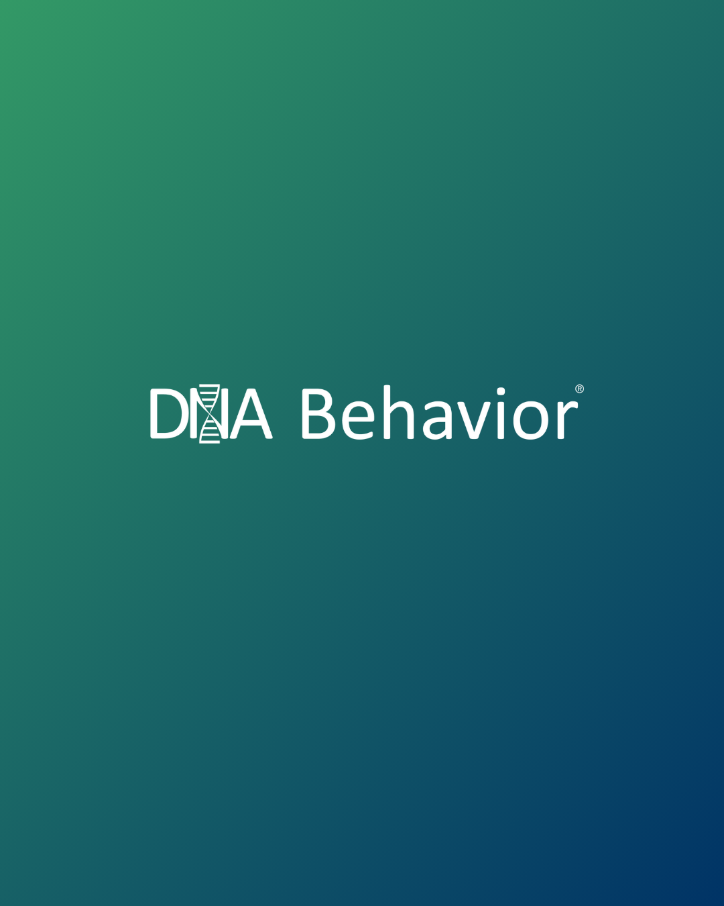

Financial Behavior Driven Decision-Making

August 2025

**Financial Behavior Driven Decision-Making**

**Abstract - Evidence Supporting DNA Behavior’s Methodology**

This paper synthesizes peer‑reviewed research examining how personality traits—primarily the Big Five (OCEAN)—predict financial behaviors and decisions. Evidence spans outcomes such as credit‑card debt, savings, risk tolerance, and investment biases, supporting DNA Behavior’s science‑based methodology by aligning its trait‑behavior linkages with independent findings.

**1. Introduction**

The study of how psychological traits influence financial decision-making has gained substantial empirical support over the past two decades [Open Journals](https://openjournals.libs.uga.edu/fsr/article/download/3178/3113?utm_source=chatgpt.com). Personality frameworks such as the **Big Five model** and behavioral economics research have revealed strong links between stable (enduring) traits and financial outcomes.

DNA Behavior’s proprietary psychometric methodology, developed since 2001 with an independent team of experts, leverages these scientific foundations to predict and guide financial behavior at both the individual and organizational level.

The measurement of stable traits or otherwise referenced as natural “hard-wired” behavior is achieved by deploying the DNA Natural Behavior Discovery Process. The DNA Natural Behavior Discovery Process uses the Forced Choice Scoring method to remove situational bias and thereby gain a high level of predictability with a scientifically proven 97.1% accuracy level. You can learn more at [www.dnabehavior.com/our-methodology](http://www.dnabehavior.com/our-methodology)

This paper reviews evidence connecting the Big 5 personality traits to financial behaviors, biases, and decisions, showing that DNA Behavior’s approach is corroborated by peer-reviewed research.

**2. The Big Five Personality Traits and Financial Decisions**

A growing body of research demonstrates that the **Big Five traits** reliably predict financial attitudes and behaviors:

**2.1 Conscientiousness**

* Strongest predictor of **positive financial outcomes** such as higher savings, lower debt, and long-term planning.
* Linked to consistent **bill payment** and **debt repayment**, with one study showing conscientiousness predicts whether individuals pay off or revolve credit card debt.
* Reflects **future orientation and self-control**, traits highly aligned with prudent financial management.

**2.2 Neuroticism**

* Associated with **financial anxiety**, pessimistic return expectations, and panic-driven decisions during market downturns.
* Individuals high in neuroticism tend to prefer **overly conservative portfolios**, which can hinder wealth accumulation over time.

**2.3 Openness to Experience**

* Linked to **financial innovation and risk-taking**, including exploration of new ideas, early adoption of cryptocurrency and preference for equities.
* However, higher openness is sometimes correlated with **lower debt repayment discipline**, suggesting trade-offs between novelty-seeking and financial prudence.

**2.4 Extraversion**

* Associated with **greater financial confidence** and, in some studies, higher earnings.
* However, extroverts are also prone to **impulse spending**, which can reduce savings.

**2.5 Agreeableness**

* Research shows mixed results: in some cases, linked to **lower wealth accumulation** (due to generosity or vulnerability to scams), but also to **risk aversion** and conservative investing.
* Highlights how social preferences influence financial trade-offs between personal security and helping others.

**3. The Big Five Personality Traits and Behavioral Biases**

Beyond general financial tendencies, personality traits amplify or buffer common **behavioral biases**:

* **Overconfidence Bias**: Often linked to **extraversion**, leading to excessive trading or underestimation of risk.
* **Loss Aversion and Panic Selling**: Amplified by **neuroticism**, causing individuals to sell prematurely during downturns.
* **Present Bias (Short-termism)**: Associated with **low conscientiousness** and high impulsivity.
* **Herding and Social Influence**: More pronounced in **agreeable** individuals, who may over-rely on peer advice.
* **Risk-taking Biases**: Strongly tied to **openness**, where innovation-seeking may outweigh rational evaluation of risks.

This mapping of personality to behavioral biases aligns with DNA Behavior’s science-based profiling of **behavioral styles** and its predictive models for financial decision-making.

**4. Reconciling Big 5 Personality Traits to DNA Behavior Trait Measurement**

The DNA Natural Behavior Discovery Process measures 8 primary factors of behavior with sixteen primary traits. We have reconciled these DNA Behavior traits to the Big 5 in the table below.

In most cases, DNA Behavior has measured financial behavior using multiple traits to achieve higher accuracy. However, each of the individual DNA Behavior traits used in measuring financial behavior are internally correlated and correlated to the Big 5 model.

|  |  |  |
| --- | --- | --- |
| **Behavior Exhibited** | **Big Five Model** | **DNA Behavior Traits** |
| Higher savings, lower debt (debt repayment), long-term planning and self-control. | Conscientiousness | Planned, Reserved |
| Financial anxiety | Neuroticism | Outgoing, Patient (low Financial EQ) |
| Financial innovation and risk-taking | Openness to Experience | Creative, Risk-Taker |
| Impulse spending | Extraversion | Outgoing, Spontaneous |
| Generosity, scamming potential, risk aversion | Agreeableness | Co-operative, Patient, Trusting, Cautious |
| Financial goal driven | Low Agreeableness | Pioneering, Take Charge |
| Overconfidence bias, over trading and under-estimation of risk | Extraversion | Outgoing, Risk-Taking, Fast Paced, |
| Loss aversion and panic selling | Neuroticism | Patient, Outgoing (low Financial EQ) |
| Present bias | Low Conscientiousness | Spontaneous |
| Herding and social influence | Agreeableness | Outgoing and Co-operative |
| Risk-taking biases | Openness | Risk-Taker (Bold and Risk-Tolerant, Creative and Take-Charge |

**5. Literature Review**

**5.1 Credit Card Behavior & Debt**

Greene, Shy, and Stavins (2023) find that when controlling for demographics and income, credit‑card adopters who are **less conscientious**, **more open**, or **more agreeable** are significantly more likely to revolve credit‑card debt [Federal Reserve Bank of Boston+2Federal Reserve Bank of Atlanta+2](https://www.bostonfed.org/-/media/Documents/Workingpapers/PDF/2023/wp2304.pdf?utm_source=chatgpt.com).

**5.2. Investment Decisions & Risk**

Recent working papers (NBER) show that stable personality differences shape both investment beliefs and behaviors [ScienceDirect+1](https://www.sciencedirect.com/science/article/pii/S0304405X23002167?utm_source=chatgpt.com).

Further, research on UK retail investors indicates personality traits are more determinant of financial risk tolerance than emotional states [ScienceDirect](https://www.sciencedirect.com/science/article/pii/S0275531921001227?utm_source=chatgpt.com).

**5.3 Financial Planning Outcomes**

Campbell, Exley, and Doyle (2023) provide a narrative review—mapping Big Five traits to outcomes like financial literacy, income, net worth, and risk tolerance, with strategic recommendations for advisors [ScienceDirect+15Open Journals+15Federal Reserve Bank of Atlanta+15](https://openjournals.libs.uga.edu/fsr/article/download/3178/3113?utm_source=chatgpt.com).

**5.4 Household Finances & Debt**

Longitudinal analysis of British Household Panel Survey data reveals significant relationships between Big Five traits and unsecured debt and financial assets [ScienceDirect+1](https://www.sciencedirect.com/science/article/pii/S016748701400083X?utm_source=chatgpt.com).

**5.5 Investment Biases**

A recent study published in *Emerald* investigated associations between the Big Five and nine common investment biases, further moderated by financial literacy [Emerald](https://www.emerald.com/rbf/article/17/1/172/1240049/The-Big-5-personality-traits-and-investment-biases?utm_source=chatgpt.com).

**5.6 Personality & Financial Well-Being**

Historical studies connecting traits like materialism, compulsive buying, saving, and debt suggest independent effects of personality on financial wealth and management [ScienceDirect](https://www.sciencedirect.com/science/article/pii/S0167487012000876?utm_source=chatgpt.com).

**6. Key Findings at a Glance**

* **Debt behavior (credit‑card debt)**: Clients low in **Conscientiousness** or higher in **Openness** or **Agreeableness** are more likely to revolve debt, even after controlling for income and demographics [ScienceDirect](https://www.sciencedirect.com/science/article/pii/S016748701400083X?utm_source=chatgpt.com)[Federal Reserve Bank of Boston+2Federal Reserve Bank of Atlanta+2](https://www.bostonfed.org/-/media/Documents/Workingpapers/PDF/2023/wp2304.pdf?utm_source=chatgpt.com).
* **Investment style & risk tolerance**: Stable traits drive investment beliefs and decisions. Personality predicts risk tolerance even more strongly than mood or situational factors [ScienceDirect+1](https://www.sciencedirect.com/science/article/pii/S0275531921001227?utm_source=chatgpt.com)[NBER](https://www.nber.org/system/files/working_papers/w31041/w31041.pdf?utm_source=chatgpt.com).
* **Financial planning outcomes**: Traits map to financial literacy, net worth, income, and risk tolerance—meaning advisors can better tailor advice using personality insights [Open Journals](https://openjournals.libs.uga.edu/fsr/article/download/3178/3113?utm_source=chatgpt.com).
* **Debt & assets**: Long-term data shows that personality traits influence debt accumulation and asset ownership [ScienceDirect](https://www.sciencedirect.com/science/article/pii/S016748701400083X?utm_source=chatgpt.com).
* **Biases in investing**: Big Five traits align with common investment biases, and financial literacy can modify these tendencies [Emerald+2ResearchGate+2](https://www.emerald.com/rbf/article/17/1/172/1240049/The-Big-5-personality-traits-and-investment-biases?utm_source=chatgpt.com).

**7. Why This Matters for Advisors**

Understanding personality helps:

* Anticipate clients’ likely financial behaviors and pitfalls.
* Adjust communication and strategies to fit clients’ trait profiles.
* Build segmentation frameworks aligning advice with behavioral predispositions.

**8. Practical Takeaways**

|  |  |  |
| --- | --- | --- |
| Trait Insight | Financial Behavior | Advisor Action |
| Low Conscientiousness | High likelihood of revolving credit‑card debt | Emphasize budgeting, reminders, automation |
| High Openness | Exploration of new products, may lack discipline | Guide experimentation with guardrails |
| Low Risk Tolerance | Avoidance of necessary growth opportunities | Educate on balanced risk and long-term gain |
| Susceptibility to Biases | More reactive to market noise | Maintain rational framework in planning |

**9. References (APA Style)**

* Campbell, W. K., Exley, J., & Doyle, P. C. (2023). *The Big Five Personality Traits (OCEAN) and Financial Planning: A Narrative Review and Recommendations for Advisors*. Financial Services Review, 31(4), 228–245. [5 Traits Test+4Open Journals+4en.wikipedia.org+4](https://openjournals.libs.uga.edu/fsr/article/download/3178/3113?utm_source=chatgpt.com)[Federal Reserve Bank of Atlanta+1](https://www.atlantafed.org/-/media/documents/banking/consumer-payments/research-data-reports/2023/07/20/RDR-personality-traits-and-financial-outcomes.pdf?utm_source=chatgpt.com)[ScienceDirect+7kiplinger.com+7JIER+7](https://www.kiplinger.com/retirement/these-traits-lead-to-more-retirement-savings?utm_source=chatgpt.com)[ScienceDirect+4Quizlet+4JETIR+4](https://quizlet.com/study-guides/the-big-five-personality-traits-in-financial-advising-c7d00f5b-8b82-46fe-b2c0-6fb32c3bb1fb?utm_source=chatgpt.com)
* Greene, C., Shy, O., & Stavins, J. (2023). *Personality Traits and Financial Outcomes* (Federal Reserve Research Working Paper No. 23‑2). Federal Reserve Banks of Boston and Atlanta. [Federal Reserve Bank of Boston+2Federal Reserve Bank of Atlanta+2](https://www.bostonfed.org/-/media/Documents/Workingpapers/PDF/2023/wp2304.pdf?utm_source=chatgpt.com)
* *Household finances and the ‘Big Five’ personality traits*. (2014). Journal of Economic Psychology, (British Household Panel Survey).
* *Personality differences and investment decision-making*. (2025). NBER Working Paper.
* *The impact of personality traits on attitude to financial risk*. (2021). Journal of Behavioral and Experimental Finance.
* *The Big 5 personality traits and investment biases: the role of …* (2025). *Emerald* journal.
* *The Big Five personality traits, material values, and financial well-being*. (2012). Journal examining savings, debt, and compulsive buying.

**Learn More:**

Learn more about the DNA Behavior Methodology at**:** [**www.dnabehavior/start**](http://www.dnabehavior/start)

**Contact**

**Hugh Massie**  
Founder – Behavioral AI Solutions Architect  
📧 hugh.massie@dnabehavior.com  
🌐 [www.dnabehavior.com](http://www.dnabehavior.com)